**LAB REPORT 1**

EMERGING WEB TECHNOLOGIES IN NEXT 5 YEARS:

In today’s world, web technologies are everywhere and they are becoming more and more advanced every year.

**Motion UI**

Clean and simple UI was a trend for the last several years. Nothing change in this approach, but in 2019 websites become more alive. Motion UI elements add interactivity to your website which enhances user experience. This approach will help your website to stand out from the crowd of static websites.

**Chatbots and customer support**

According to Gartner, over [85% of customer](http://www.businessinsider.com/sc/chatbots-future-customer-service-2016-9) interactions will happen through chatbots by 2020. Moreover, AI will be integrated mostly into chatbots in the next five years. Chatbots have found their application mostly in customer service. People can shop via chatbots, pay for bills or ask information. In addition to better customer service, it saves money for business by reducing the number of employees.

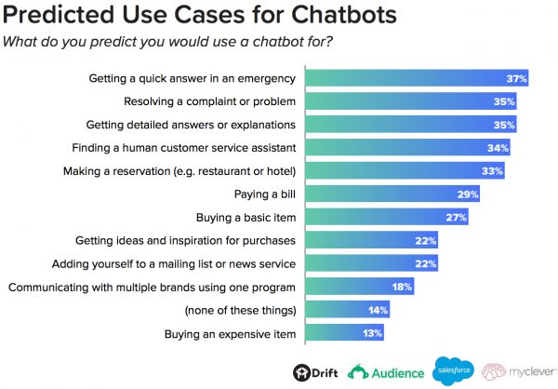

**Web Assembly**

Websites are using JavaScript to make calculations and create animations. But websites are becoming more and more complex and JavaScript is not powerful enough to provide satisfying performance. Notice, that the most powerful applications and games are accessible only as desktop applications. But [Web Assembly](https://webassembly.org/)(wasm) can change the game be providing the desktop-like performance in the web. Web Assembly, compiles the native code like C++ into bytecode that can be rendered in the browser. This technology enhances web applications and is definitely worth trying out.

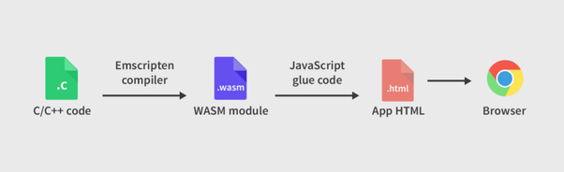

**Machine learning & Artificial intelligence**

Machine learning and artificial intelligence become a trend last year and are already frequently used by companies. Machine learning detects patterns and can make decisions by itself. It’s also a part of neural networks. This technology gives the opportunity to highly enhance the user experience by creating a personalized experience. Moreover, such machine learning abilities as image/text recognition can add powerful features to your service or business processes. Machine learning is already being used in web applications in various industries, such as retail, education, healthcare, agriculture, finance etc.

[Artificial intelligence](https://dashbouquet.com/blog/artificial-intelligence/machine-learning-and-ai-trends-for-2018-what-to-expect) place a huge role in today’s business digital transformation. And as more and more companies implement this technology, AI starts to play an even bigger role in web development. Gartner [says](https://www.gartner.com/en/newsroom/press-releases/2019-01-24-gartner-predicts-70-percent-of-organizations-will-int), that in 2019, more than 70% of companies in the world will implement artificial intelligence to increase productivity and customer satisfaction. Moreover, [according to Statista](https://www.statista.com/statistics/607716/worldwide-artificial-intelligence-market-revenues/), the AI market size will be rapidly growing for the next 5 years and will hit 11 billion dollars in 2019. All of this leads to the conclusion that AI will be a leading trend in 2019.

**Cybersecurity**

Every day we share an enormous amount of personal data with websites: credit card details, our preferences, our search history, and our private communication. And of course, every one of us wants this data to be secured and encrypted. Moreover, organizations store their documents and clients databases on the cloud. That’s why a lot of companies invest in cybersecurity and with emerging of AI technology, it becomes a new trend as cybersecurity becomes more advanced. For example, AI can prevent fraud in ecommerce websites or detect suspicious activity.

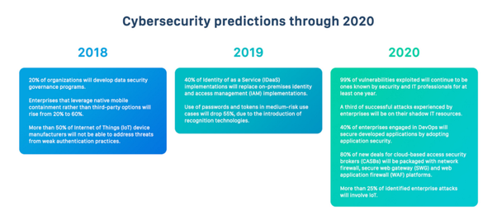

**Blockchain**

Blockchain was on hype due to cryptocurrencies and have lost some trust because of that. But cryptocurrencies and crypto wallets are only one implementation of this technology.

Another blockchain implementation is dapps (decentralized apps). The uniqueness of such applications is the database is made on the blockchain. As a result, the application can’t be controlled by any authority like company or individum. Moreover, blockchain creates an opportunity to prove the authenticity of contracts or ownership as every transaction is saved inside blockchain and can’t be deleted. This forms a range of new projects and features that can be created with the usage of the blockchain.

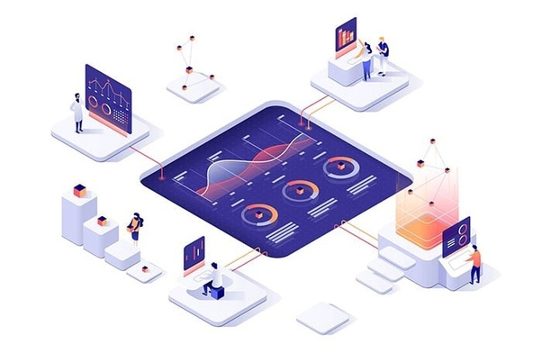

The dapps were originally built as native applications, but are confidentially moving to the web.

The most popular open-source platform for blockchain projects Ethereum has built a JavaScript library [web3.js](https://github.com/ethereum/web3.js). This library allows easy interaction between Ethereum blockchain and web application in various ways, such as creating smart contracts, reading and writing data, transferring ether between accounts, etc. So building decentralized apps on the web is becoming easier. Blockchain has passed its peak of hype, but it’s still an interesting, trending and futuristic technology that can transform your business for the best.

**Voice search**

Voice search is slowly becoming a part of everyday life with the rapid growth of voice assistants like Siri or Google Assistant. Moreover, it was [predicted](https://www.wix.com/blog/2017/09/voice-search-changing-seo/) that by 2020 **50%** of allsearches will be done by voice.

Voice interfaces are becoming so popular because of ease of use, affordability and a low learning curve for children and elders.Voice search has found its main implementation in e-commerce. However, it is also suitable for other businesses around the web. If you want your website to be found, consider optimizing it for voice search as soon as possible.

**Single Page Applications (SPAs)**

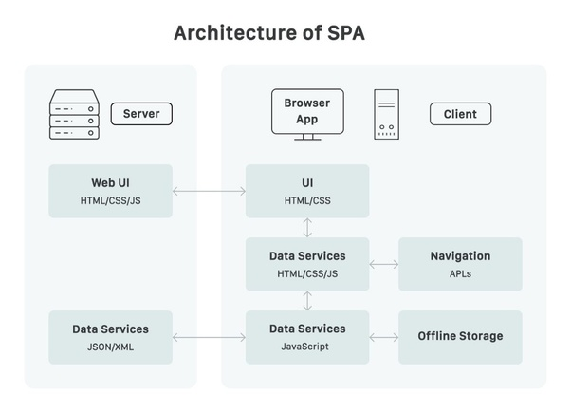

SPAs are flourishing in the modern web. They have speed and performance in their core. That’s why single page applications provide users with the best browsing experience due to the absence of delays and page reloads during the navigation.

**Progressive web apps (PWA) and accelerated mobile pages (AMP)**

One more trend is adaptivity for the mobile web. Google encourages websites that load fast on mobile devices because now people browse more from mobile devices than from desktop. That’s why you should implement [PWA](https://medium.com/elligense-team/what-is-pwa-and-how-it-increases-customer-engagement-and-conversions-real-life-examples-f32b4bddcda9?source=friends_link&sk=503736a6e9df61c20368c197e66d88b2) or AMP on your website.A progressive web application (PWA) is a website that can be added to the home screen as a mobile app and provide a native-like experience by remaining a website. The key features of PWA are an offline mode, high performance, push notifications, native-like experience. This technology is effectively used in ecommerce websites.

An accelerated mobile page (AMP) are regular static pages that display only the essential information — text, images, etc., omitting fancy decorations. Moreover, Google caches such pages on their servers, so the page loads in milliseconds, when opened from Google. This technology works perfectly well for blogs and news publishers. The choice of technology depends on the type of your website, but you definitely should consider optimizing your pages for mobile devices to increase your search rankings.

**Low-code Development**

Low-code development means reusing components and API’s to build websites faster and easier. In other words, stop to reinvent the wheel.

There are also low-code development platforms that enable rapid delivery of business applications with a minimal upfront investment in setup, training, and deployment.

Low code development platforms open such opportunities:

* Innovate faster and work smarter
* Enhance customer experience
* Improve operational efficiency
* Stay on to of changing risk and regulations

**Internet of things(IoT)**

The Internet is no more used by people only, it’s also accessed by smart devices like speakers, watches and even thermostats. Websites now display information from sensors and can send commands to devices. Moreover, you should consider adapting your website to tiny screens like smart watches.



**Technology stack for web application development**

It is important to stay updated and use modern web technologies. Below you will find top technologies in 2019 for both front-end and back-end.

**Front-end technologies:**

* **Angular**Angular is a Model-View-Controller (MVC) framework which allows you to write a well-structured and efficient code. Angular uses two-way data binding, which means that UI fields are bound to model dynamically, the changes in model change the UI and visa versa.  
  Moreover, note that Angular uses Typescript which is different from JavaScript.
* **React.js**React has become very popular for building web applications and SPAs over the past several years.  
  React uses JSX, an HTML inside JS which enable to create reusable components and build high-performance applications. We have to mention that React is not a framework, rather a library (but is often called a framework). That means, that other third-party libraries have to be used to make a React project up and running. Nevertheless, this library is worth using for powerful web applications.
* **Vue.js**Vue.js is the youngest among popular web technologies but has already proven its powers and become popular among developers. Bytheway, [our company’s website](https://elligense.com/) uses Vue.  
  The main feature of Vue.js is that its lightweight and works right out of the box. Moreover, it works perfectly well with other libraries.  
    
  All three frameworks are popular and powerful, the choice depends on your business needs or development preferences.

**Back-end technologies:**

* **Node.js**Node.js is usually used with frameworks mentioned above to build server-side part of the application. The benefit of using this technology is that you can have your whole application working on JavaScript only.
* **Django**Django is a Python web framework used for the back-end. It works perfectly well with front-end frameworks and is a good choice for any type of website due to a range of third-party packages.
* **Laravel**Php is a pioneer among web back-end languages and Larravel is it’s and trendy framework that helps to build high-performance web applications. This is the framework we at **Elligense** love the most.
* **Kotlin**Kotlin is a new programming language, an alternative to Java that is very easy to learn. It is used by Slack and Netflix and other companies start to implement it.  
  Though Kotlin is mostly used to build Android apps, it can also be used for developing server-side or back-end applications.
* **Elixir and Phoenix**[Phoenix](https://phoenixframework.org/) framework is a part of [Elixir](https://elixir-lang.org/) programming language and is on hype in the developer community. Phoenix is fast, reliable and productive, it brings web applications to the next level of performance.  
  Nevertheless, you still should check if this technology is suitable for your type of project. Elixir and Phoenix are the best fit in real-time applications, like chat applications, where the speed of dataflow is a priority. But Elixir will perform worth on application where computing power is needed.
* **GraphQL**[GraphQL](https://graphql.org/), is a quite new open-source query language developed by Facebook. Nowadays, it’s one of the most popular technologies to build APIs. GraphQL makes loading and processing data much efficient by enabling the ability to specify exactly which data you want to get back from the API. It loads only the necessary data and reduces the network load, which increases app performance.

**5G Technology**

5G technologies and edge computing stimulate multi-experience trend development. A new generation of wireless technology provides a greater speed of transmissions and wider opportunities to deliver excellent AR/VR experience. We come to the term of fit-for-purpose apps: IT companies worldwide get ready to provide seamless experience all over mobile and web extensions, as well as wearables and conversational devices.

5G – the next generation of wireless

5G, or the fifth generation of mobile network technology, is the successor to 4G LTE. Beneath this simple definition, however, lies much confusion and some disagreement about what 5G is and when the world can expect to experience the full range of possibilities it has to offer. This confusion stems from the lack of adherence to a single industry standard for 5G, as well as the uneven nature in which the technology will be rolled out. Yet there is no doubt that 5G will prove transformational for its users.